Data Preprocessing

Creating Training and Test Sets in Machine Learning

Splitting a dataset into training and test sets is a fundamental step in machine learning. It ensures that a model is trained on one subset and evaluated on another to measure generalization performance.

1. Why Split Data?
- Training Set → Used to train the model.
- Test Set → Used to evaluate the model's performance on unseen data.
- Helps prevent overfitting by ensuring the model is tested on new data.

2. Standard Train-Test Split Using Scikit-Learn

The common split ratio is 80% for training and 20% for testing.

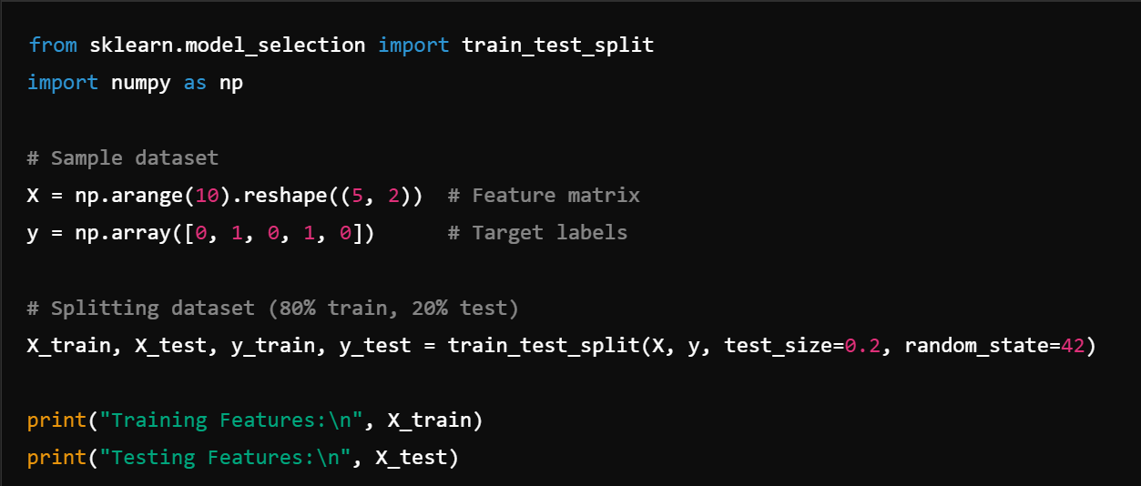

✅ random_state=42 ensures reproducibility.

3. Stratified Sampling for Imbalanced Data

If the dataset is imbalanced, stratified sampling ensures class distribution remains the same in both sets.

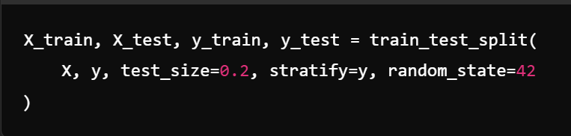

✔ Stratified Sampling maintains class proportions across train-test sets.

4. Train-Validation-Test Split

For better performance evaluation, datasets are often split into three parts:
- Training Set (70%) → Used for training.
- Validation Set (15%) → Used for hyperparameter tuning.
- Test Set (15%) → Used for final evaluation.

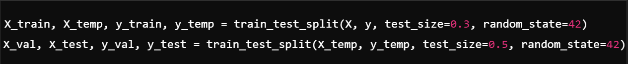

5. Cross-Validation (CV) Instead of a Single Split

Instead of one train-test split, cross-validation (CV) improves robustness by training multiple times on different splits.

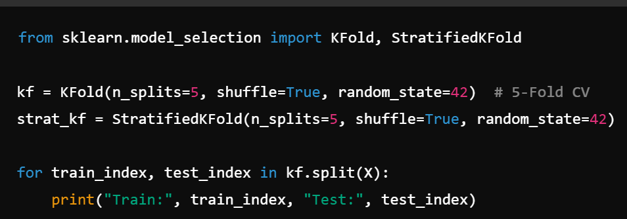

✔ Cross-validation provides a more reliable performance estimate.

Conclusion
- Basic Split: train_test_split()
- Stratified Split for imbalanced data.
- Train-Validation-Test Split for hyperparameter tuning.
- Cross-Validation (CV) for robust evaluation.
Feature Scaling

Feature scaling is the process of normalizing or standardizing the range of numerical features so that they contribute equally to the model. This is especially important for algorithms that rely on distance calculations (e.g., KNN, SVM) or gradient-based optimization (e.g., neural networks).

Why Feature Scaling?
- Ensures that features with larger scales do not dominate those with smaller scales.
- Improves convergence speed in gradient-based algorithms.
- Enhances model performance and stability.

Types of Feature Scaling:

- Normalization (Min-Max Scaling):
  - Scales features to a fixed range, usually [0, 1].
  - Formula:

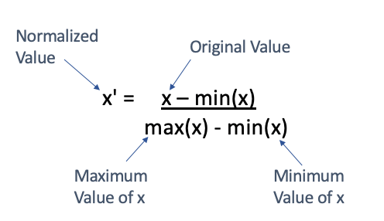

  - Example: Scaling pixel values (0-255) in images to [0, 1].

- Standardization (Z-Score Scaling):
  - Scales features to have a mean of 0 and a standard deviation of 1.
  - Formula:
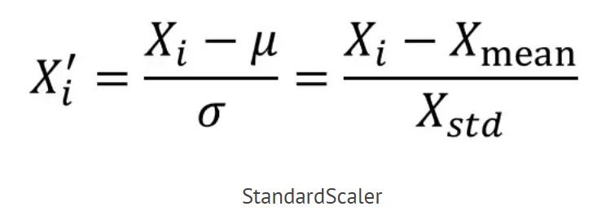

  - Example: Scaling features like age, income, or height for regression models.

- Robust Scaling:
  - Uses the median and interquartile range (IQR) to scale features, making it robust to outliers.
  - Formula:

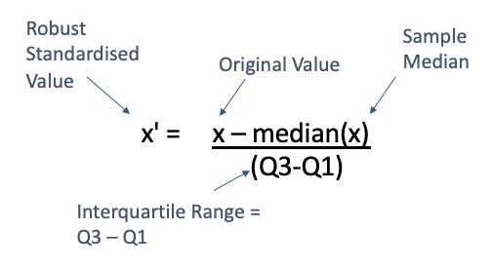

  - Example: Scaling data with outliers, such as income data.

Feature Engineering: Enhancing Machine Learning Models

Feature engineering is the process of creating, transforming, and selecting features to improve the performance of a machine learning model.

1. Why is Feature Engineering Important?
- Improves model accuracy and performance.
- Reduces overfitting by removing irrelevant features.
- Helps models learn better patterns from data.
- Reduces training time by eliminating unnecessary features.

2. Types of Feature Engineering

(A) Creating New Features

Adding new derived features to improve learning.

🔹 Example: Extracting Date Features

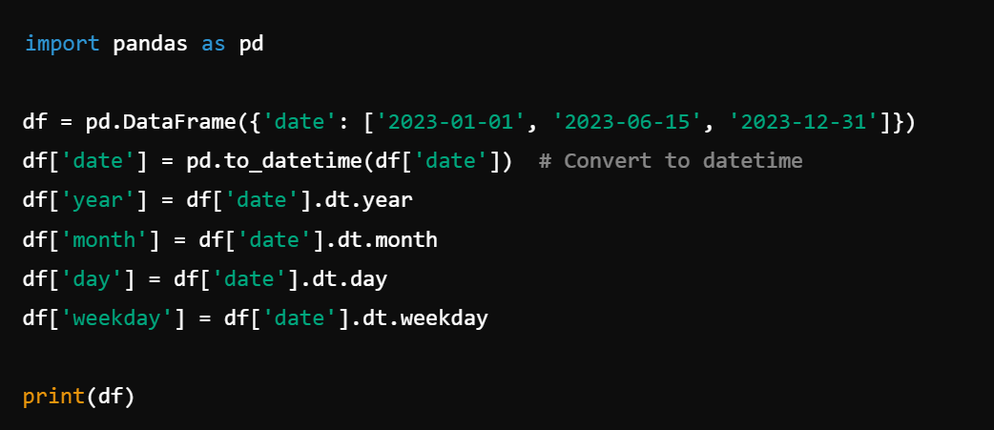

✔ Helps models learn seasonal trends.

🔹 Example: Feature Interaction (Multiplying Features)

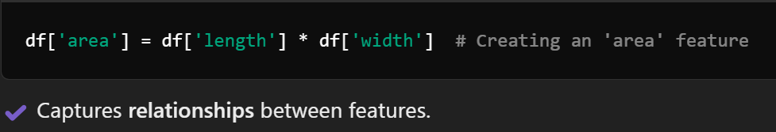

(B) Modifying Features

Changing existing features to improve model performance.

🔹 1. Log Transformation (Handling Skewed Data)

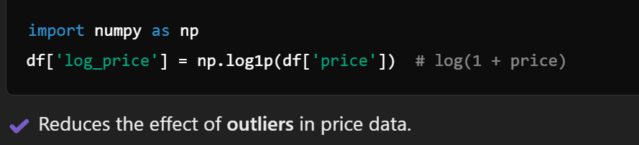

✔ Reduces the effect of outliers in price data.

🔹 2. Scaling Features (Standardization & Normalization)

Standardization (Z-score Normalization):

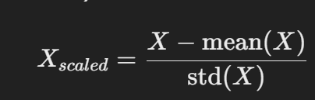

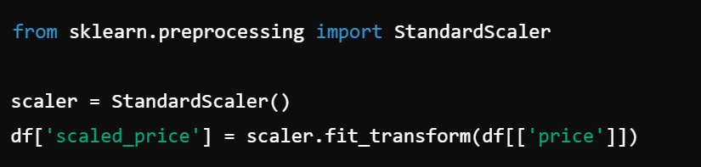

✔ Useful for linear models, SVMs, and PCA.
- Min-Max Scaling (0 to 1 Range): 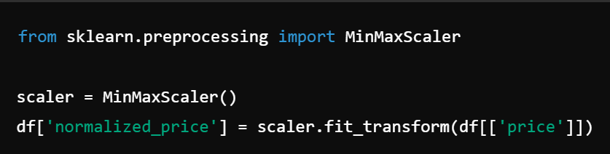
- ✔ Useful for Neural Networks & Gradient Descent models.

(C) Handling Missing Data
- 🔹 1. Filling with Mean/Median/Mode

🔹 2. Using Forward/Backward Fill (for Time Series)

(D) Encoding Categorical Variables

🔹 1. One-Hot Encoding

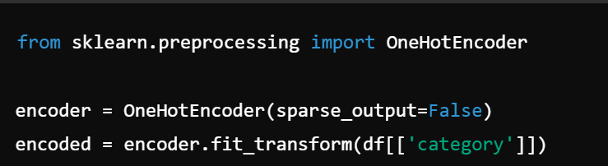

✔ Best for Nominal (unordered) categories.

🔹 2. Label Encoding

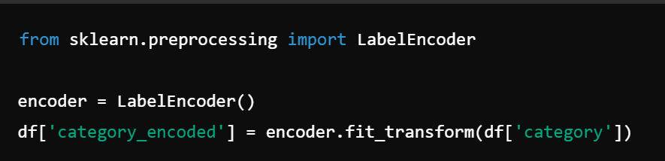

✔ Best for Ordinal (ordered) categories.

3. Feature Selection (Removing Unnecessary Features)

🔹 Removing Low-Variance Features

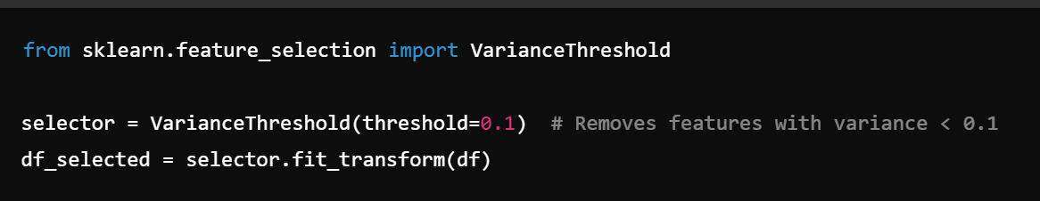

✔ Helps remove redundant features.

🔹 Using Feature Importance (Random Forest)

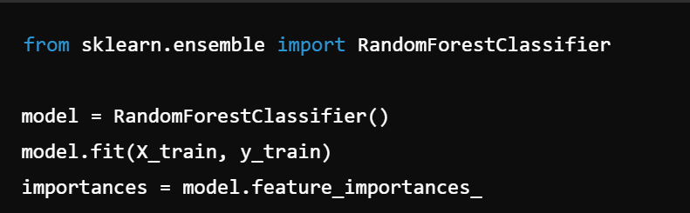

✔ Helps identify important features.

Conclusion

✅ Feature Engineering is crucial for improving model performance.
✅ Includes creating new features, modifying data, and selecting important features.
✅ Helps reduce training time and improve accuracy.

Data Cleaning – Treating Missing Values and Outliers

Data cleaning is a critical step in the data preprocessing pipeline. It involves identifying and addressing issues like missing values and outliers to ensure the data is accurate, consistent, and ready for analysis or modeling. Poor data quality can lead to incorrect conclusions and poor model performance.

Treating Missing Values
Missing values occur when no data is stored for certain features in a dataset. They can arise due to errors in data collection, processing, or storage. Handling missing values is essential because most machine learning algorithms cannot work with incomplete data.
Common Techniques to Handle Missing Values:
- Remove Missing Data:
  - Drop rows or columns with missing values.
  - Use when the amount of missing data is small and random.
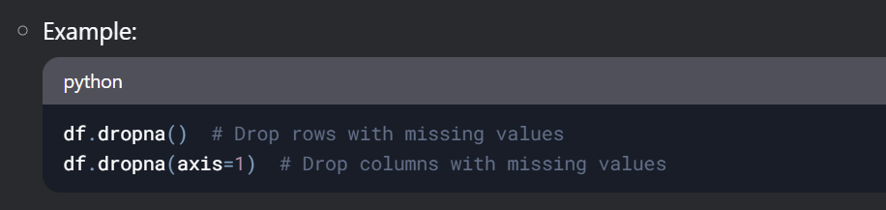

- Imputation:
- Fill missing values with estimated or calculated values.
- Common methods:
  - Mean/Median/Mode Imputation: Replace missing values with the mean (for numerical data), median (for skewed data), or mode (for categorical data).
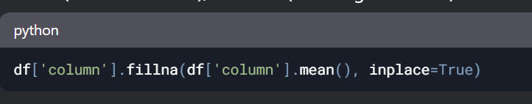
  - Forward/Backward Fill: Use the previous or next value in the dataset (common in time-series data).

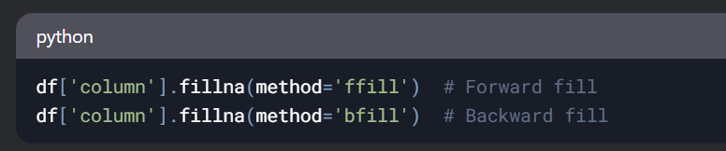

  - Predictive Imputation: Use machine learning models (e.g., regression, KNN) to predict missing values.

- Flagging Missing Values:
  - Create a new binary feature to indicate whether a value was missing.
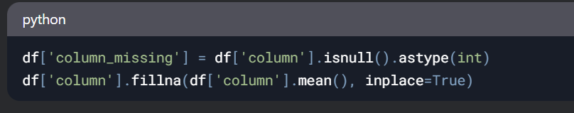
- Advanced Techniques:
  - Use algorithms like MICE (Multiple Imputation by Chained Equations) for complex datasets.
  - Use deep learning models for imputation in high-dimensional data.

Treating Outliers
Outliers are data points that deviate significantly from the rest of the data. They can arise due to errors (e.g., data entry mistakes) or natural variability (e.g., extreme values in a distribution). Outliers can skew analysis and negatively impact model performance.

Common Techniques to Handle Outliers:
- Visual Inspection:
  - Use plots like boxplots, scatterplots, or histograms to identify outliers.
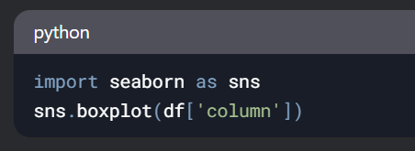

Statistical Methods:
- Z-Score: Identify outliers as data points with a Z-score greater than a threshold (e.g., |Z| > 3).
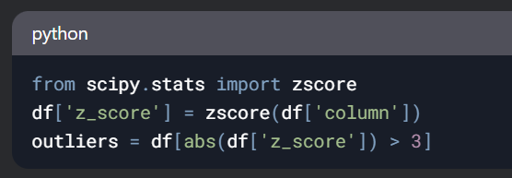

IQR (Interquartile Range): Identify outliers as data points outside 1.5 * IQR from the quartiles.
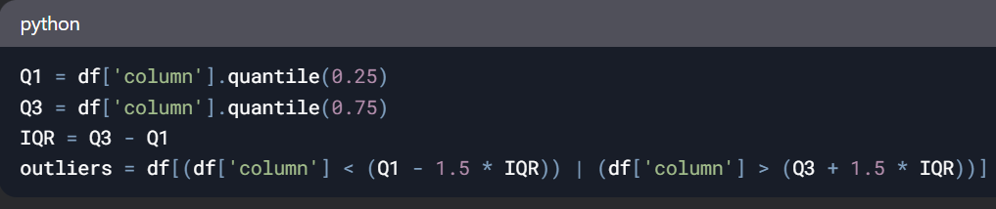

Removing Outliers:
- Drop rows containing outliers.
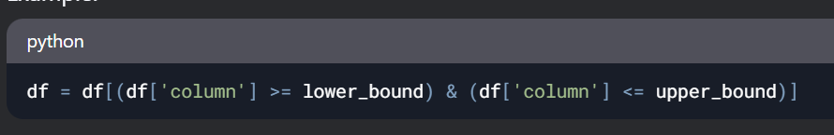

Capping/Truncating:
- Replace outliers with a specified upper or lower limit.
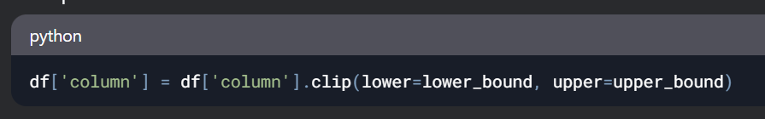

Transforming Data:
- Apply transformations like log, square root, or Box-Cox to reduce the impact of outliers.
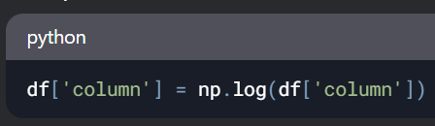
Binning:
- Convert continuous data into discrete bins to reduce the effect of outliers.
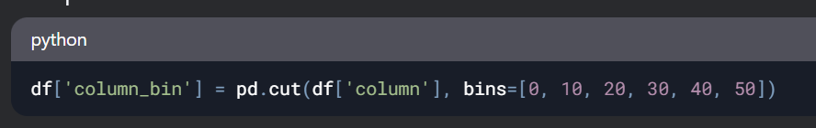

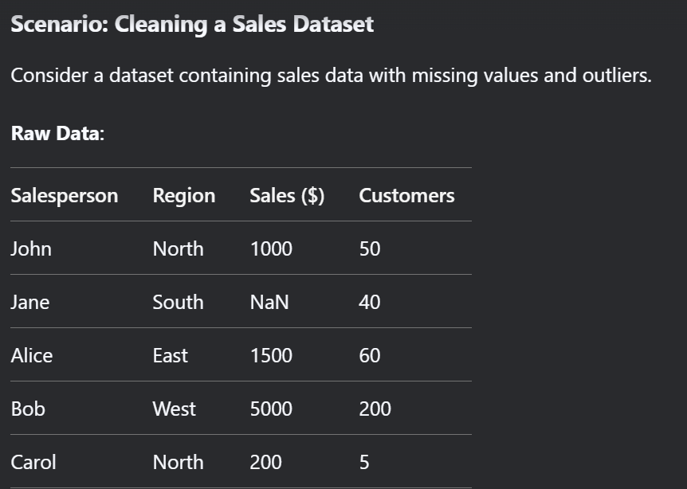

Data Cleaning Steps:
- Treat Missing Values:
  - Impute the missing Sales value for Jane using the mean sales value.
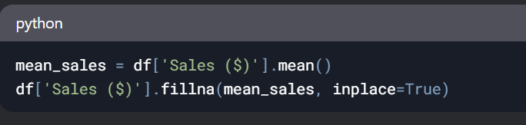

Treat Outliers:
- Identify outliers in Sales ($) using the IQR method.
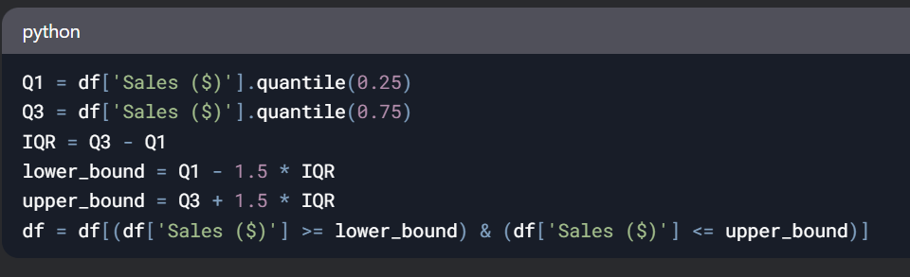
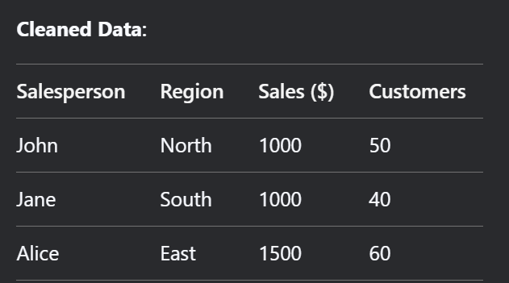

Why Data Cleaning is Important
- Improves Data Quality: Ensures the dataset is accurate and reliable.
- Enhances Model Performance: Clean data leads to better model training and predictions.
- Reduces Bias: Proper handling of missing values and outliers prevents skewed results.
- Saves Time: Clean data reduces the need for repeated debugging and corrections during analysis.

DATA WRANGLING
Encoding Categorical Data

Categorical data represents discrete values that belong to specific categories. Since most machine learning algorithms work with numerical data, categorical data must be converted into numerical form.

Types of Categorical Data:

- Nominal Categorical Data:
  - Categories with no inherent order or ranking.
  - Examples: Gender (Male, Female), Color (Red, Blue, Green), Country (USA, India, Japan).

- Ordinal Categorical Data:
  - Categories with a meaningful order or ranking.
  - Examples: Education Level (High School, Bachelor’s, Master’s, PhD), Rating (Poor, Fair, Good, Excellent).

Encoding Techniques:

- Label Encoding:
  - Assigns a unique integer to each category.
  - Suitable for ordinal data.
  - Example:
    - Education Level: Tall→ 0, Medium → 1, Short → 2.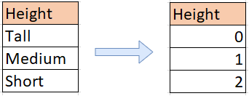
- One-Hot Encoding:
  - Creates binary columns for each category.
  - Suitable for nominal data.
  - Example:
    - Color: Red → [1, 0, 0], Blue → [0, 1, 0], Green → [0, 0, 1].

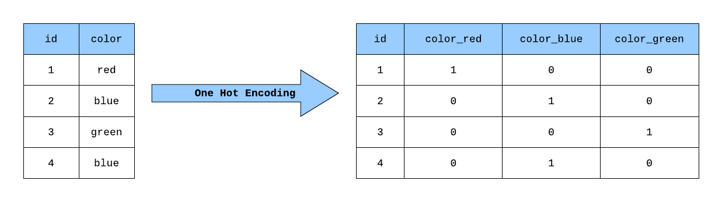
- Ordinal Encoding:
  - Assigns integers to categories based on their order.
  - Suitable for ordinal data.
  - Example:
    - Rating: Poor → 1, Good → 2, Very Good → 3, Excellent → 4.

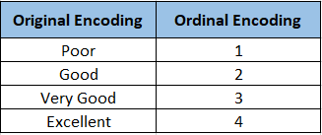

- Target Encoding (Mean Encoding):
  - Replaces categories with the mean of the target variable for that category.
  - Useful for high-cardinality categorical data.
  - Example:
    - City: Replace each city name with the average house price in that city.
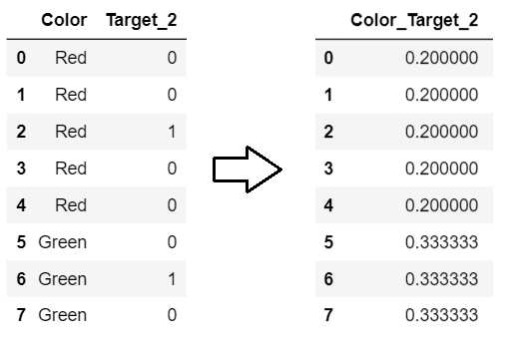

Data Types

1. Numerical Data:
- Represents quantifiable values.
- Continuous Data: Can take any value within a range.
  - Examples: Height, Weight, Temperature.
- Discrete Data: Can only take specific, distinct values.
  - Examples: Number of children, Number of cars.

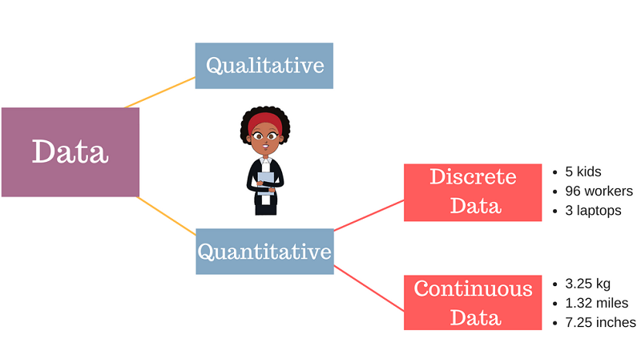

2. Categorical Data:
- Represents discrete categories or groups.
- Nominal Categorical Data: No inherent order.
  - Examples: Gender, Country, Color.
- Ordinal Categorical Data: Has a meaningful order.
  - Examples: Education Level, Rating, Income Level (Low, Medium, High).

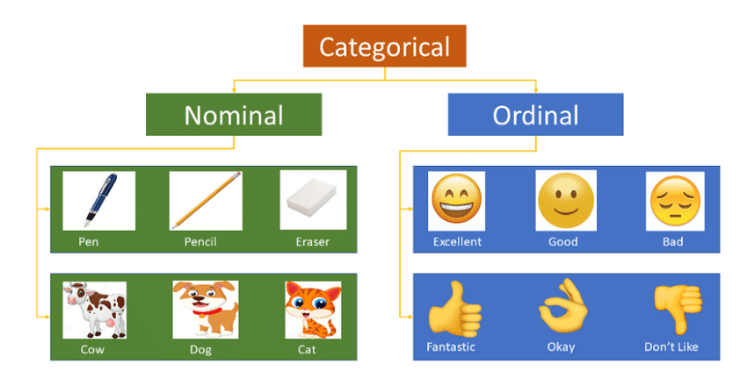

Examples of Feature Engineering
- Feature Scaling:
  - Scaling house sizes (in square feet) and prices (in dollars) to the same range for a regression model.
  - Standardizing age and income features for a clustering algorithm.
- Encoding Categorical Data:
  - One-hot encoding "Country" (USA, India, Japan) for a classification model.
  - Label encoding "Education Level" (High School, Bachelor’s, Master’s, PhD) for an ordinal regression model.

Feature Engineering – Adding New Features and Modifying Data
Feature engineering is the process of creating new features or modifying existing ones to improve the performance of machine learning models. It involves using domain knowledge, creativity, and data manipulation techniques to extract more meaningful information from raw data.

Why is Feature Engineering Important?
- Improves Model Performance: Well-engineered features can significantly enhance a model's ability to capture patterns and relationships in the data.
- Reduces Overfitting: By creating relevant features, the model can focus on the most important aspects of the data, reducing the risk of overfitting.
- Handles Non-Linearity: Many machine learning algorithms assume linear relationships. Feature engineering can introduce non-linear relationships that better represent the data.
- Domain-Specific Insights: Incorporating domain knowledge into feature creation can lead to more interpretable and effective models.

Key Techniques in Feature Engineering
- Adding New Features:
  - Create new features by combining or transforming existing ones.
  - Examples:
    - Interaction Features: Multiply or divide two features (e.g., Income / Family Size).
    - Polynomial Features: Create higher-order terms (e.g., x2x2, x3x3).
    - Aggregation Features: Summarize data (e.g., average, sum, max, min).
    - Time-Based Features: Extract day, month, or year from a date.
- Modifying Data:
  - Transform or clean existing features to make them more useful.
  - Examples:
    - Log Transformation: Reduce skewness in data (e.g., log(Income).
    - Binning: Convert continuous data into discrete bins (e.g., age groups: 0-18, 19-35, 36-60, 60+).
    - Handling Missing Values: Impute missing data using mean, median, or predictive models.
    - Normalization/Standardization: Scale features to a common range.

Scenario: Predicting House Prices
Let’s consider a scenario where we want to predict house prices based on features like size, location, number of bedrooms, and age of the house.
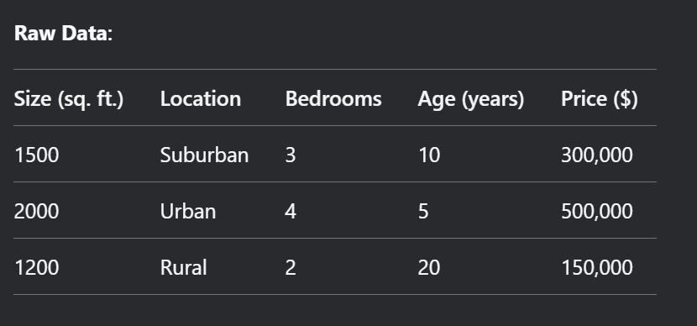

Feature Engineering Steps:
- Adding New Features:
  - Price per Square Foot: Create a new feature by dividing Price by Size.


- Location Encoding: Convert the categorical feature Location into numerical values using one-hot encoding.
  - Suburban → [1, 0, 0]
  - Urban → [0, 1, 0]
  - Rural → [0, 0, 1]
- Age Group: Bin the Age feature into categories (e.g., 0-10, 11-20, 20+).
Modifying Data:
- Log Transformation: Apply a log transformation to Price to handle skewness.

- Normalization: Normalize Size and Bedrooms to a range of [0, 1] to ensure equal contribution
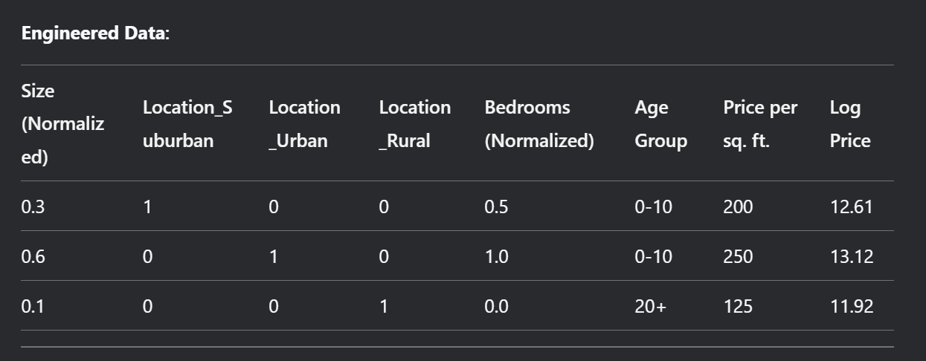

Why This is Important in the Scenario
- Price per Square Foot: Captures the relationship between size and price, making it easier for the model to understand value.
- Location Encoding: Converts categorical data into a numerical format that the model can process.
- Age Group: Simplifies the Age feature into meaningful categories, reducing noise.
- Log Transformation: Reduces skewness in the target variable (Price), improving model performance.
- Normalization: Ensures that features like Size and Bedrooms contribute equally to the model.
By adding and modifying features, we provide the model with more meaningful and interpretable inputs, leading to better predictions and insights. This is the essence of feature engineering!

Feature Transformations

Feature transformation changes the representation of data while preserving its information.

(A) Log Transformation

Used to handle skewed distributions and reduce the impact of outliers.

🔹 Example:

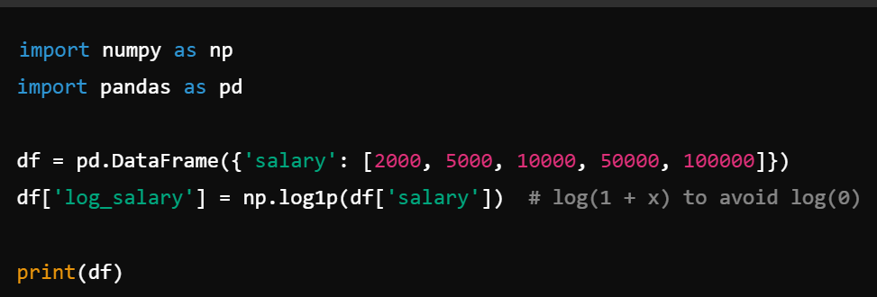

✔ Helps normalize skewed data.

(B) Square Root & Cube Root Transformation

Used when log transformation is too aggressive.

🔹 Example:

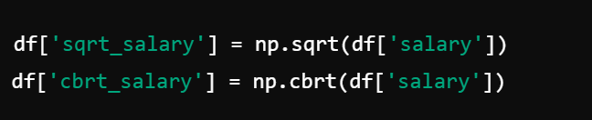

✔ Useful for reducing large variations in data.

(C) Box-Cox & Yeo-Johnson Transformation

Used to make data closer to normal distribution.

🔹 Example:

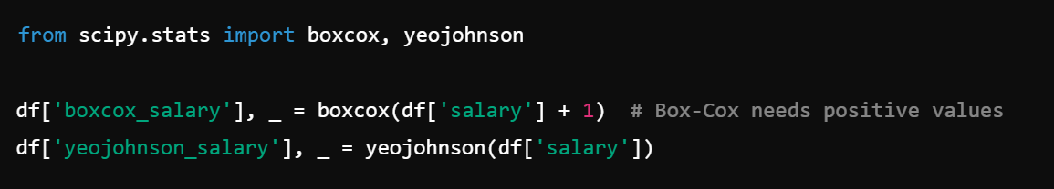

✔ Box-Cox works only on positive values, Yeo-Johnson works on both positive & negative values.

(D) Binning (Discretization)

Converts continuous variables into discrete bins.

🔹 Example:

✔ Useful for decision trees and rule-based models.

(E) Polynomial Features (Feature Expansion)

Used to add complexity by creating polynomial combinations.

🔹 Example:

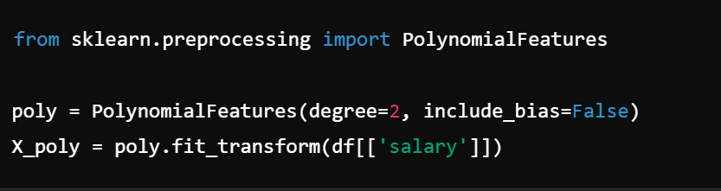

✔ Helps in non-linear models like polynomial regression.

2. Feature Scaling

Feature scaling ensures all features are on the same scale, improving model training and convergence.

(A) Standardization (Z-Score Normalization)

Converts data to have mean = 0 and standard deviation = 1.

🔹 Formula:

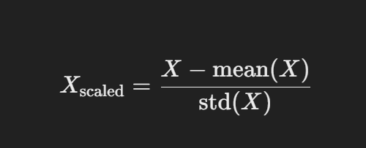

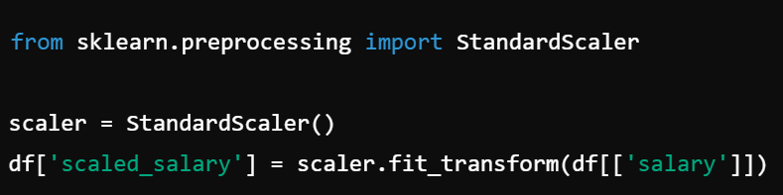

✔ Works well for SVM, PCA, K-Means, Linear Regression.

(B) Min-Max Scaling (Normalization)

Scales data between 0 and 1.

🔹 Formula:

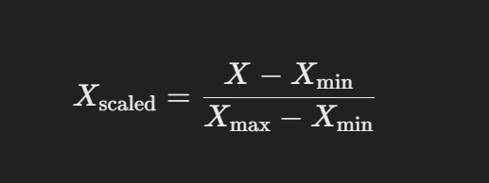

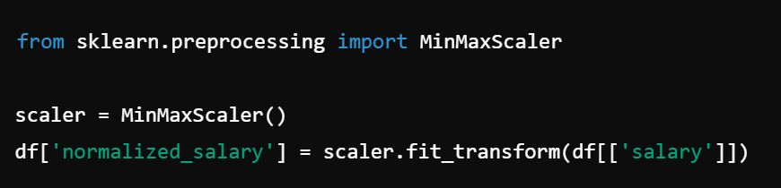

✔ Best for Neural Networks and Gradient Descent-based models.

(C) Robust Scaling (Resistant to Outliers)

Scales data using median and interquartile range (IQR).

🔹 Formula:

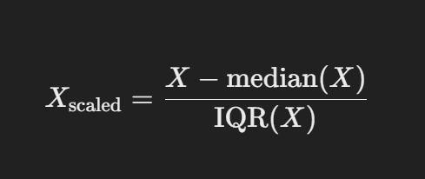

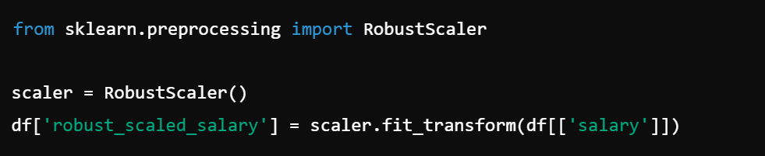

✔ Works well when data has outliers.

Conclusion

✅ Feature Transformation helps make data more suitable for learning by changing its representation.
✅ Feature Scaling ensures models perform efficiently by making data comparable.
✅ Choice of transformation/scaling depends on model requirements and data distribution.

Feature Selection
Feature selection is the process of selecting the most relevant features (variables) from a dataset to improve model performance, reduce overfitting, and enhance interpretability. It helps in removing irrelevant, redundant, or noisy features, making the model more efficient and effective.

Types of Feature Selection Methods
1. Filter Methods
Filter methods evaluate the relevance of features based on statistical measures and select features independently of the machine learning algorithm. They are computationally efficient and work well for high-dimensional datasets.
Common Techniques:
- Correlation Coefficient:
  - Measures the linear relationship between features and the target variable.
  - Example: Pearson correlation for continuous data, Spearman correlation for ordinal data.
  - Features with high correlation (absolute value) are selected.
- Chi-Square Test:
  - Used for categorical features to test the independence between the feature and the target.
  - Example: Selecting categorical features for classification tasks.
- Mutual Information:
  - Measures the dependency between features and the target variable.
  - Suitable for both continuous and categorical data.
- Variance Threshold: 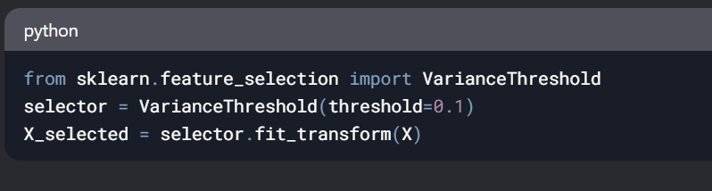
  - Removes features with low variance (e.g., constant or near-constant features).
Advantages:
- Fast and scalable.
- Independent of the machine learning algorithm.
Disadvantages:
- Ignores feature interactions.
- May not capture complex relationships.
2. Wrapper Methods
Wrapper methods evaluate subsets of features by training and testing a specific machine learning model. They use the model's performance as the evaluation criterion and search for the optimal feature subset.
Common Techniques:
- Forward Selection:
  - Starts with no features and iteratively adds the best-performing feature.
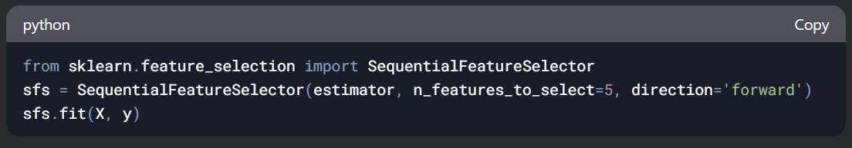

Backward Elimination:
- Starts with all features and iteratively removes the least significant feature.
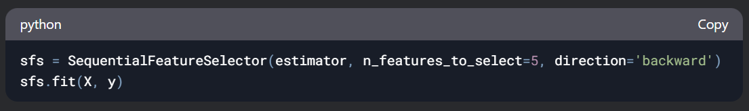

Recursive Feature Elimination (RFE):
- Recursively removes the least important features based on model weights (e.g., coefficients in linear models).

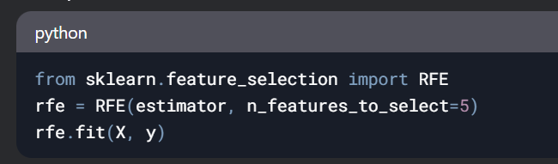

- Exhaustive Search:
  - Evaluates all possible feature subsets (computationally expensive).
Advantages:
- Considers feature interactions.
- Optimizes model performance.
Disadvantages:
- Computationally expensive.
- Prone to overfitting.

Embedded Methods
Embedded methods perform feature selection as part of the model training process. They combine the advantages of filter and wrapper methods by considering feature interactions and being computationally efficient.
Common Techniques:
- Lasso Regression (L1 Regularization):
  - Adds a penalty term to the loss function, forcing some feature coefficients to zero.
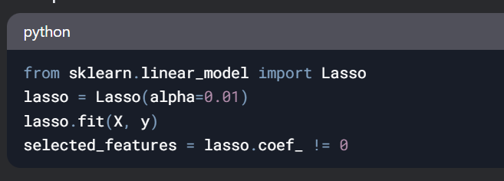
Ridge Regression (L2 Regularization):
- Adds a penalty term to shrink coefficients but does not force them to zero.
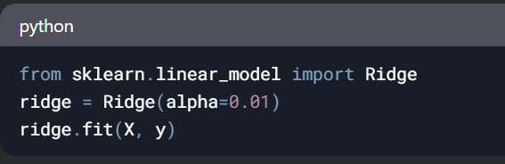

Tree-Based Methods:
- Use feature importance scores from tree-based models (e.g., Random Forest, Gradient Boosting).
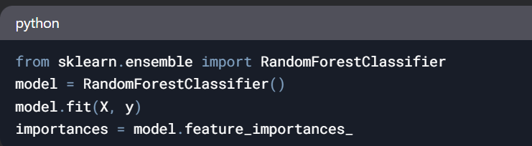

- Elastic Net:
  - Combines L1 and L2 regularization for feature selection.
Advantages:
- Computationally efficient.
- Considers feature interactions.
Disadvantages:
- Model-specific (depends on the algorithm used).
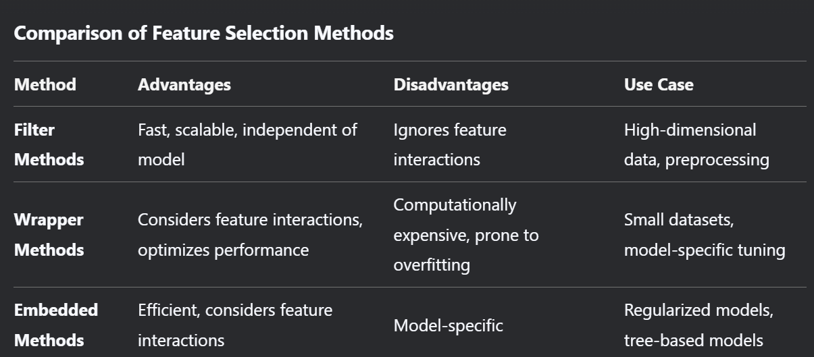

Scenario: Feature Selection for a Classification Problem
Consider a dataset with 20 features for predicting whether a customer will churn.
Steps:
- Filter Method:
  - Use correlation to select the top 10 features most correlated with the target variable.
- Wrapper Method:
  - Use Recursive Feature Elimination (RFE) with a logistic regression model to select the top 5 features.
- Embedded Method:
  - Use Lasso regression to identify features with non-zero coefficients.
Result:
- Filter method reduces features to 10.
- Wrapper method further reduces features to 5.
- Embedded method confirms the importance of the selected features.
Why Feature Selection is Important
- Improves Model Performance: Reduces overfitting and enhances generalization.
- Reduces Training Time: Fewer features mean faster model training.
- Enhances Interpretability: Simplifies the model and makes it easier to understand.
- Handles High-Dimensional Data: Essential for datasets with many features (e.g., text, images).
Dimensionality Reduction Techniques – PCA

Dimensionality reduction is the process of reducing the number of features (variables) in a dataset while retaining as much meaningful information as possible. It is crucial for improving model performance, reducing computation time, and removing noise from data.

1. Principal Component Analysis (PCA)
PCA is a statistical technique used to transform high-dimensional data into a lower-dimensional space while preserving the variance of the original dataset. It finds a new set of axes (principal components) that maximize variance and project the data onto these axes.
📌 Steps in PCA
Step 1: Standardize the Data
Since PCA is affected by different scales of features, the data should be standardized to have zero mean and unit variance. This ensures that all features contribute equally.
Formula for standardization:
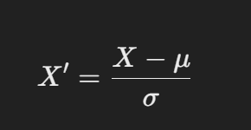

where X is the original feature, μ is the mean, and σ is the standard deviation.

🔹 Python Code Example
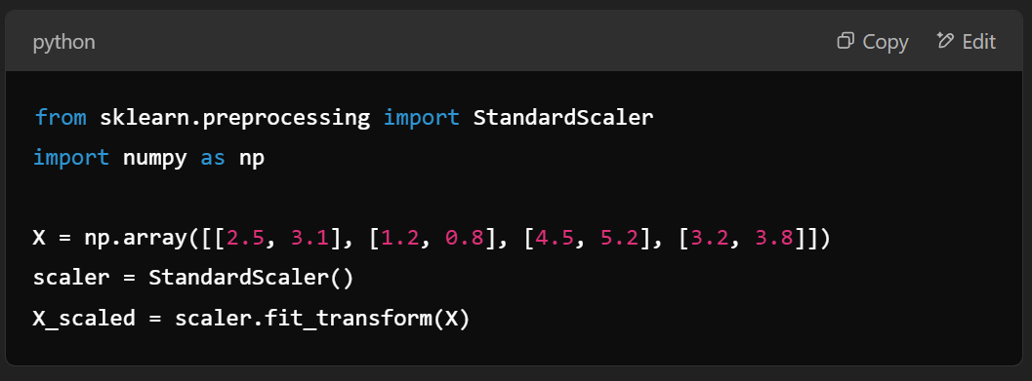

Step 2: Compute the Covariance Matrix
The covariance matrix represents how features vary together. It is calculated as:
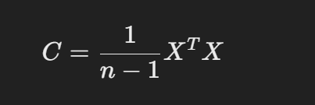

where X is the standardized data matrix.
🔹 Python Code Example
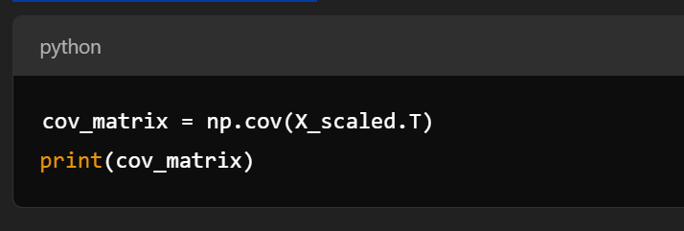

Step 3: Compute Eigenvalues and Eigenvectors
Eigenvalues measure the variance explained by each principal component, while eigenvectors define the direction of these components.
🔹 Python Code Example
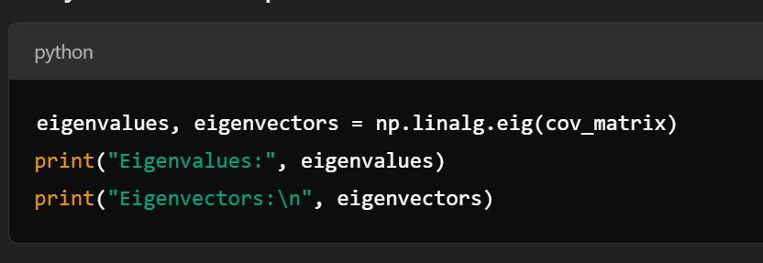

Step 4: Select Top k Principal Components
Sort the eigenvalues in descending order and select the top k components that explain the most variance. The explained variance ratio is given by:
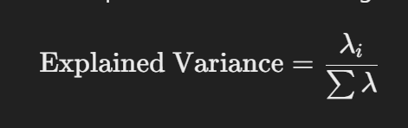

where λi​ are the eigenvalues.
🔹 Python Code Example
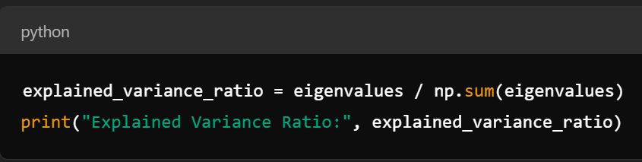

Step 5: Project Data onto the New Feature Space
The original data is transformed using the selected eigenvectors to obtain reduced dimensions.
🔹 Python Code Example
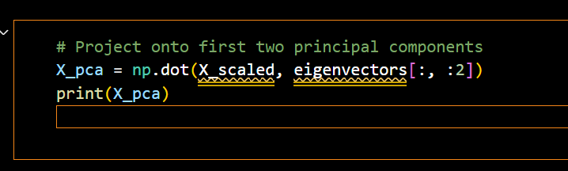

📌 Variants of PCA
Sparse PCA
- Introduces sparsity constraints on principal components to select fewer influential features.
- Useful when dealing with highly correlated features.
🔹 Use Case: Gene expression data, where only a few genes contribute to a condition.

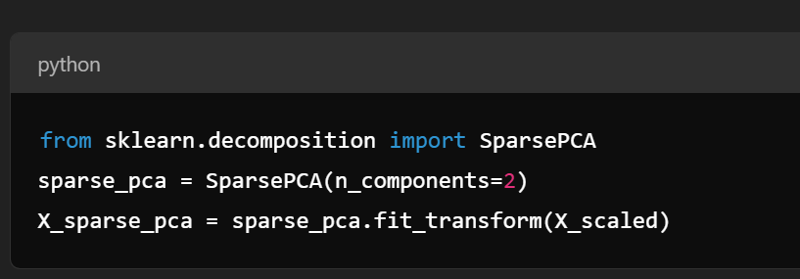
Kernel PCA
- Extends PCA to non-linear data using kernel functions (e.g., polynomial, RBF, sigmoid).
🔹 Use Case: Facial recognition, where data is non-linearly distributed.
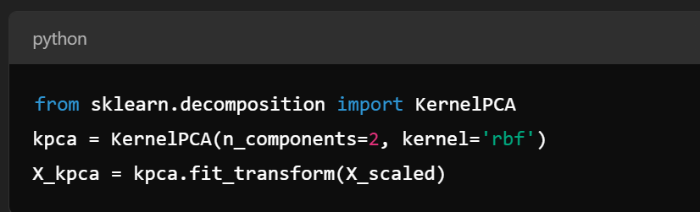

Singular Value Decomposition (SVD)

SVD is another dimensionality reduction technique that decomposes a matrix AAA into three matrices:
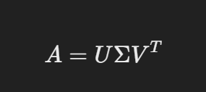
where:
- U = Left singular vectors (orthogonal matrix)
- Σ = Diagonal matrix of singular values
- V^T = Right singular vectors (orthogonal matrix)

📌 Steps in SVD
Step 1: Compute SVD
🔹 Python Code Example

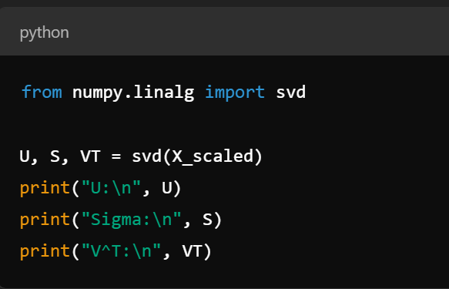
Step 2: Select k Largest Singular Values
Singular values in Σ represent variance in data. We select the top k values to reduce dimensionality.

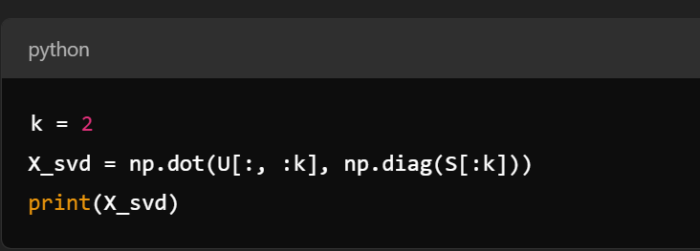
📌 Differences Between PCA and SVD
Feature | PCA | SVD
Input Data | Covariance Matrix | Original Matrix
Purpose | Reduces dimensions while maximizing variance | Decomposes matrix for various applications
Computation | Uses eigenvalues & eigenvectors | Uses singular values & orthogonal matrices
Suitability | Used for feature reduction | Used for feature extraction & noise reduction

📌 Key Takeaways
✅ PCA is a variance-based method that projects data onto principal components.
✅ Sparse PCA adds sparsity for better feature selection.
✅ Kernel PCA is useful for non-linear transformations.
✅ SVD decomposes a matrix into meaningful components and is useful for data compression.

Non-Negative Matrix Factorization (NMF)

📌 What is NMF?
Non-Negative Matrix Factorization (NMF) is a dimensionality reduction technique used to decompose a non-negative matrix into two lower-dimensional non-negative matrices. Unlike PCA or SVD, NMF ensures that all elements remain non-negative, making it useful for interpretability in applications like topic modeling, image processing, and recommender systems.
📌 Mathematical Representation
Given a non-negative matrix A of size m×n, NMF factorizes it into two non-negative matrices:
A≈W×H
where:
- W is an m×k matrix (basis matrix).
- H is a k×n matrix (coefficient matrix).
- k is the number of latent features (usually k<n for dimensionality reduction).

📌 Steps in NMF
- Step 1: Prepare the Data
- Ensure that all elements in the matrix are non-negative. NMF does not work with negative values.
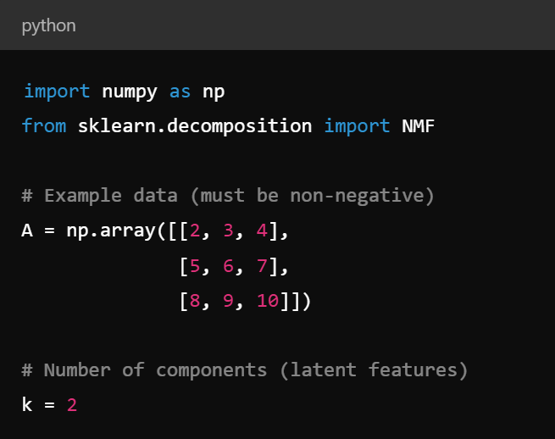

Step 2: Apply NMF
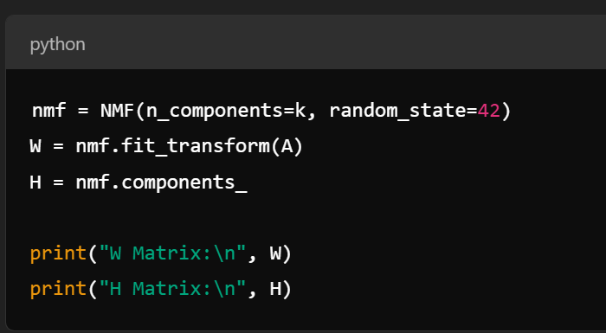

Step 3: Reconstruct the Original Matrix
To approximate A, multiply W and H.
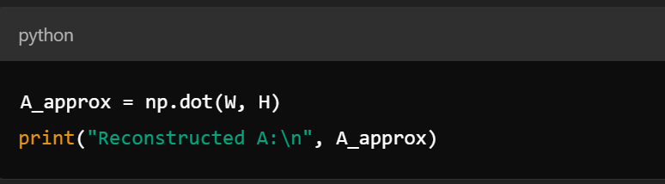


📌 Applications of NMF
✅ Topic Modeling – Extracts topics from text documents.
✅ Recommender Systems – Used for collaborative filtering (e.g., movie recommendations).
✅ Image Processing – Feature extraction in images.
✅ Bioinformatics – Identifying gene expression patterns.

Interview Question

Creating Training and Test Sets

Q1. Why do we split data into training and test sets?
A1. To evaluate model performance on unseen data and prevent overfitting.

Q2. What is the typical ratio for splitting data into training and test sets?
A2. Common splits:
- 80/20 (80% training, 20% testing)
- 70/30 (for larger datasets)
- 90/10 (when data is limited)

Q3. What is stratified sampling, and when should you use it?
A3. Stratified sampling ensures that the train-test split maintains the same class distribution as the original dataset. It is useful for imbalanced classification problems.

Data Scaling and Normalization

Q4. What is the difference between Standardization and Normalization?
A4.
- Standardization (Z-score scaling): Converts data to have mean = 0 and standard deviation = 1.
- Normalization (Min-Max scaling): Rescales data to a fixed range, typically [0,1].

Q5. When should you use Standardization vs. Normalization?
A5.
- Standardization → When data follows a normal distribution. Used in linear models and SVM.
- Normalization → When data is skewed or has different ranges. Used in deep learning and KNN.

Q6. How do you standardize and normalize data in Scikit-Learn?

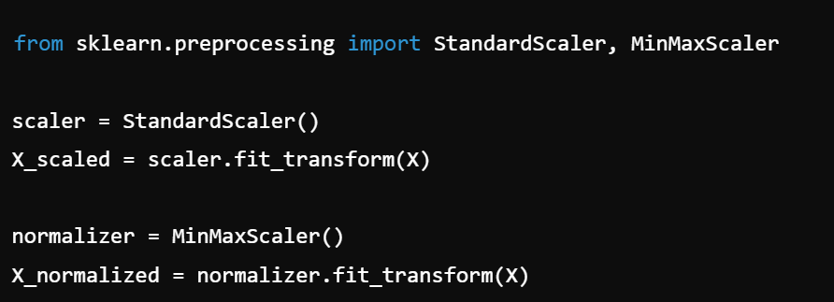

Feature Engineering

Q7. What is feature engineering, and why is it important?
A7. Feature engineering involves creating new features or modifying existing ones to improve model performance. It is crucial because better features lead to better predictions.

Q8. Give examples of feature engineering techniques.
A8.
- Adding new features (e.g., creating "age groups" from raw age values).
- Combining features (e.g., BMI = weight / height²).
- Extracting datetime features (e.g., day of the week from a timestamp).
- Log transformation (for skewed data).

Data Cleaning (Handling Missing Values and Outliers)

Q9. How do you handle missing values in a dataset?
A9.
- Drop missing values (if the missing rate is very high).
- Impute with mean/median/mode (for numerical data).
- Use forward/backward fill (for time-series data).
- Use a predictive model (e.g., KNN imputation).

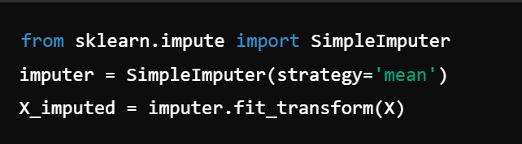

Q10. How do you detect and handle outliers?
A10.
- Z-score method (removing values beyond ±3 standard deviations).
- IQR method (removing values outside [Q1 - 1.5IQR, Q3 + 1.5IQR]).
- Winsorization (capping extreme values).

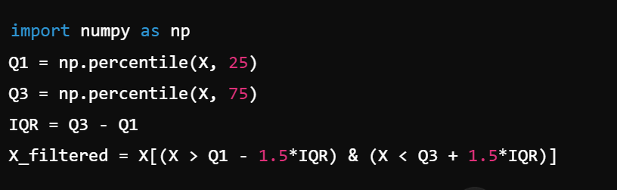

Data Wrangling (Encoding, Feature Transformations, Scaling)

Q11. What are different encoding techniques for categorical data?
A11.
- One-Hot Encoding (for nominal data)
- Label Encoding (for ordinal data)
- Target Encoding (when the categorical variable has many levels)

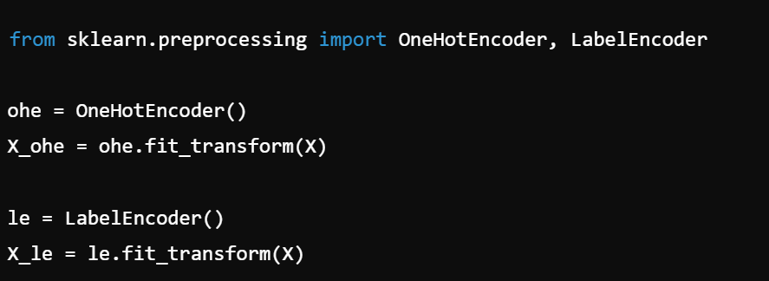

Q12. What are common feature transformation techniques?
A12.
- Log transformation (for skewed data).
- Power transformations (Box-Cox, Yeo-Johnson).
- Polynomial feature expansion (for linear models)

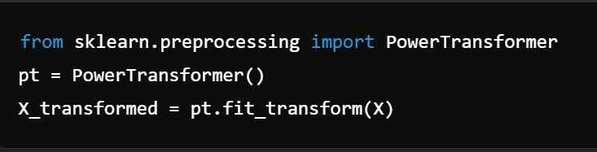

Feature Selection

Q13. What are the three main types of feature selection methods?
A13.
- Filter Methods (based on statistical tests)
  - Pearson Correlation
  - Chi-Square test
  - Mutual Information
- Wrapper Methods (based on model performance)
  - Recursive Feature Elimination (RFE)
  - Forward/Backward Selection
- Embedded Methods (built into model algorithms)
  - Lasso Regression (L1 regularization)
  - Decision Trees (Feature Importance)

Q14. How do you perform feature selection in Scikit-Learn?

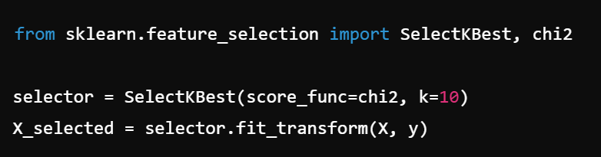

Dimensionality Reduction

Principal Component Analysis (PCA)

Q15. What is PCA, and how does it work?
A15. PCA reduces dimensionality by projecting data onto principal components that maximize variance. It helps remove noise and speed up training.

Q16. What is the difference between Sparse PCA and Kernel PCA?
A16.
- Sparse PCA: Uses L1 regularization to force some principal components to be zero.
- Kernel PCA: Uses kernel functions (e.g., RBF) to perform PCA in a higher-dimensional space.

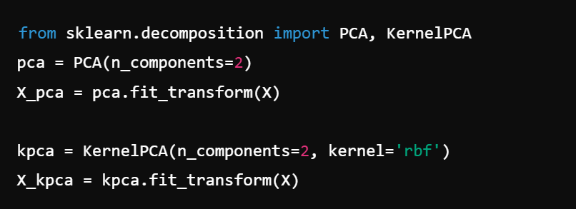

Singular Value Decomposition (SVD)

Q17. What is Singular Value Decomposition (SVD), and where is it used?
A17. SVD factorizes a matrix into three matrices: A=UΣV^{T}. It is widely used in recommendation systems and latent factor models.

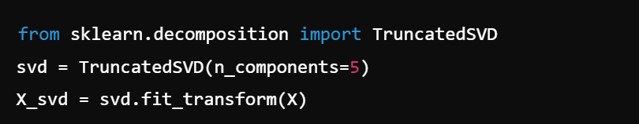

Non-Negative Matrix Factorization (NMF)

Q18. What is Non-Negative Matrix Factorization (NMF), and how is it different from PCA?
A18.
- NMF factorizes a matrix into non-negative components (unlike PCA, which allows negative values).
- Used in topic modeling, image processing, and document clustering.

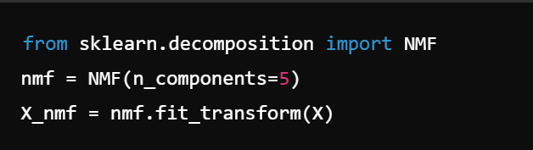

Blogs:
- Data Preprocessing and Feature Engineering in Machine Learning
https://magnimindacademy.com/blog/data-preprocessing-and-feature-engineering-in-machine-learning/
- Dimensionality Reduction in Machine Learning and Data Science
https://saeedmirshekari.com/blog/dimensionality-reduction-in-machine-learning-and-data-science/
- Introduction to Dimensionality Reduction
https://www.geeksforgeeks.org/dimensionality-reduction/.
- Feature Selection and Dimensionality Reduction
https://leehanchung.github.io/blogs/2021/04/12/Feature-Selection/
- The Art of Feature Engineering in Data Preprocessing
https://mlres.net/the-art-of-feature-engineering-in-data-preprocessing/

Kaggle Notebooks:
- Preprocessing Images with Dimensionality Reduction
https://www.kaggle.com/code/hamishdickson/preprocessing-images-with-dimensionality-reduction
- Dimensionality Reduction Techniques
https://www.kaggle.com/code/karltonkxb/dimensionality-reduction-techniques
- Data Preprocessing and Feature Engineering
https://www.kaggle.com/code/marytong/data-preprocessing-feature-engineering
- Housing Price Prediction: Advanced Regression Techniques
https://github.com/ShovalBenjer/Housing_Price_Prediction_Advanced_Regresson_Kaggle

